If you are having trouble reading this email, read the online version.




Accounts Page Enhancements in the Client Portal

As part of our ongoing effort to improve the aggregation experience in the Client Portal, your clients can soon expect a more seamless, streamlined account-linking experience within their Accounts page.
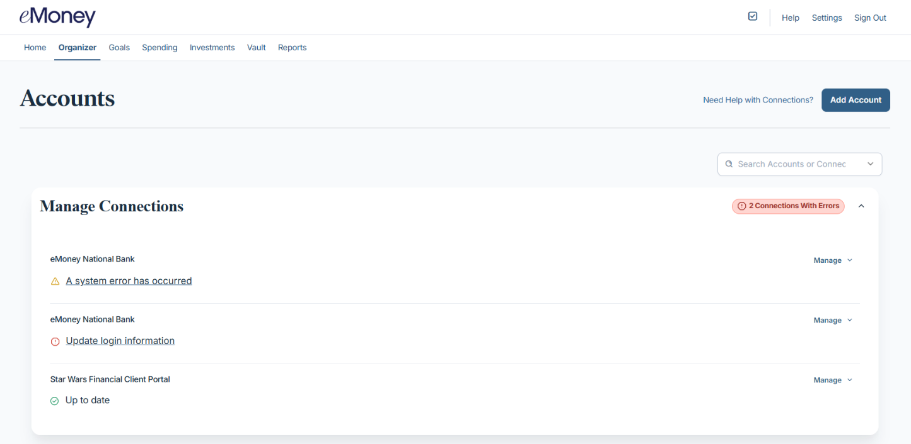
LEARN MORE

The One Big Beautiful Bill Act

The 2025 Budget Reconciliation Bill introduces changes that could impact client strategies. This post will serve as your central hub for tracking how and when these updates go live in eMoney. We recommend bookmarking this page to stay informed, as it will be updated regularly as new functionality becomes available. Learn more.

NEW CONNECTIONS AVAILABLE

​#1 Market Leader in Aggregation Tools

As the leader in data aggregation, we remain focused on helping you unlock the full potential of your clients’ financial data. See what we’ve been up to this quarter. Learn more.

NOW AVAILABLE

Client Portal Updates for an Enhanced Experience​

We’re investing in the future of the Client Portal with enhanced capabilities, new features, and the retirement of outdated tools to deliver a more modern, efficient experience for advisors and their clients. Learn more.

NOW AVAILABLE
eMoney Now Integrates with Jump AI and Black Diamond

We're expanding the way eMoney can support your business through new integrations built by our technology partners. Learn more.
SEE ALL PRODUCT UPDATES

eMoney Advisor, LLC
Four Radnor Corporate Center, 100 Matsonford Road, Suite 220, Radnor, PA 19087 888-362-4612

