Subject line: Home Office News: One Big Beautiful Bill Act (2025 Budget Reconciliation Bill)
One Big Beautiful Bill Act (2025 Budget Reconciliation Bill)
The One Big Beautiful Bill Act (2025 Budget Reconciliation Bill) introduces changes that could impact client strategies. We’ve released the first round of timely updates in eMoney to support your planning efforts, and are targeting early September for the next round. You can also listen to this short podcast episode about how eMoney is responding to the new tax legislation with Senior Financial Planning Consultant, Michelle Riiska (Posted August 12, 2025).
LEARN MORE
More Highlights
BLOG
Data Migration Services Help Migrate Platforms with Ease
This case study highlights Bridgeworth Wealth Management’s initiative to migrate financial planning data to eMoney, aiming to standardize software usage across the firm. The project overcame initial concerns about scale and complexity to successfully centralize planning operations.

COMING SOON
New Onboarding Series
Beginning this fall, new users can feel confident from day one with a refreshed onboarding experience, featuring a personalized email series that guides them through their Getting Started Program. With a warmer, more human-first approach, these automated messages promote coaching calls and self-paced learning—making engagement simple and scalable.
*Only applicable for those who utilize eMoney training/coaching services.

1-MINUTE VIDEO
How One Simple Rephrase Can Reduce Client Anxiety During Retirement Conversations
New clients may find discovery meetings stressful, especially when planning for their futures. Watch Joe Buhrmann share insights on how to ask the right questions.
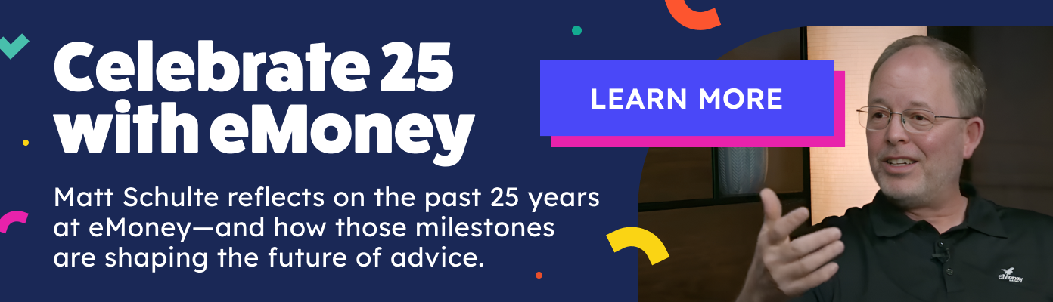
Check out the Heart of Advice blog for more insights and best practices for successful financial planning engagement.

